ONLINE BOOK STORE

A Report of the mini–Project Work submitted in partial

fulfilment of the requirements for the Degree of

BACHELOR OF COMPUTER APPLICATIONS

Submitted By: Aswin G Nair

Reg. No:180021093348

Under the guidance of

Mrs. Maria Jacob

(Assistant professor - Department of Computer Science)



Department of Computer Science

MAR AUGUSTHINOSE COLLEGE

(Affiliated to Mahatma Gandhi University)

Ramapuram-686576

2018-2021

MAR AUGUSTHINOSE COLLEGE RAMAPURAM

(Affiliated to Mahatma Gandhi University)



CERTIFICATE

This is to certify that this project work entitled “ONLINE BOOK STORE” is a bonafide report of the mini-project done by ASWIN G NAIR (Reg.No: 180021093348) during the academic year 2018-2021 for the partial fulfilment for the award of the Degree of Bachelor of Computer Applications from Mahatma Gandhi University, Kottayam.

Mr. Prakash Joseph MCA Mrs. Maria Jacob

Head of the Department Project Guide

Viva- voice Examination conducted on ……………………. at

Mar Augusthinose College, Ramapuram.

**Internal Examiner External Examiner**

**Place: Ramapuram**

DECLARATION

I, ASWIN G NAIR hereby declare that the project work entitled “**ONLINE BOOK STORE**” is a record of bonafide research carried out by me under the supervision and guidance of **Mrs. Maria Jacob**, Lecturer Department of Computer Science, Mar Augusthinose College, Ramapuram. I also declare that it has not been previously submitted for the award of any Degree, Diploma, or similar titles by any University or similar other institutions.

**Place:** Ramapuram Aswin G Nair

**Date:**

ACKNOWLEDGEMENT

First and foremost, I thank Almighty God for his gracious guidance throughout the project.

I acknowledge my deep sense of gratitude to Dr. Joy Jacob MA(English), MPhil, Ph.D., the Principal for permitting me to do this project. I take the immense pleasure in expressing my thanks to Head of Department Mr. Prakash Joseph MCA, for his kind patronages in making this project a successful one.

I would like to extend my sincere thanks to **Mrs. Maria Jacob** for her guidance and cooperation, without which this would not have been a success. This leaf of acknowledgment would not be complete without a special word of thanks to my beloved parents for their valuable support, encouragement, and love, which enabled me to bring out this project. I extend my thanks to Mr. M.J. SIBY, MA, MCP, MSE, Computer Programmer and System Administrator for his technical support, valuable advice, and guidance throughout the project. I wish to extend my thanks to the management and staff, of Mar Augusthinose College, Ramapuram, for their valuable support to carry out this project work.

**ASWIN G NAIR**

**CONTENTS**

1. INTRODUCTION-------------------------------------------------7
   1. 1.1 General Introduction----------------------------------8
   2. 1.2 Software Introduction---------------------------------9
   3. 1.3 Synopsis------------------------------------------------10
2. SYSTEM STUDY--------------------------------------------------11
   1. 2.1 System Study-------------------------------------------12
   2. 2.2 Existing System----------------------------------------13
   3. 2.3 Proposed System--------------------------------------14
3. SYSTEMANALYSIS----------------------------------------------16
   1. 3.1 Introduction---------------------------------------------17
   2. 3.2 Feasibility Study----------------------------------------17
   3. 3.3 Requirement Specification----------------------------20
   4. 3.4 Introduction to Frontend and Backend--------------21
4. SYSTEMDESIGN--------------------------------------------------27
   1. 4.1 Input Design---------------------------------------------28
   2. 4.2 Output Design-------------------------------------------29
   3. 4.3 Database Design**----------------------------------------**31
   4. 4.4 Tables----------------------------------------------------35
   5. 4.5 Data Flow Diagram------------------------------------38
5. SYSTEM TESTING------------------------------------------------45
   1. 5.1 Testing Procedures-------------------------------------46

5.2 Testing Methodologies---------------------------------47

**6. SYSTEM IMPLEMENTATION AND MAINTENANCE-51**

**7. FUTURE SCOPE OFTHE PROJECT-------------------------55**

8.CONCLUSION-------------------------------------------------------57

**9. BIBLIOGRAPHY---------------------------------------------------59**

**10. APPENDIX----------------------------------------------------------61**

# INTRODUCTION

INTRODUCTION

1.1GENERAL INTRODUCTION

A computer is an electronic device that accepts digital information and processes it in a predefined function. According to a set or sequence of instructions provided to it and produces the desired binary outputs. It is made up of input devices, storage, arithmetic, and logic circuits, and a control unit.

We are living in an information age dependent upon digital information. Digital information is electronic information, the result of computer processing. Every type of job relies upon getting information, using it, managing it, and relaying information to others. The computer enables the efficient processing and storage of information.

Computers work through the interaction of hardware and software. Hardware refers to the part of a computer that you can see and touch, including the case and everything inside it. The ability to analyse business problems and to manage the development of a complex computer-based system in an environment where information resources are proliferating are the challenges that accompany the opportunities of the future. The main advantages of computer over manual processing are:

* Accuracy
* Storage
* Speed of Response
* Data Collection and Communication
* Versatility
* Diligence

Shoppers and traders are quickly changing the mode of operation from the present way. The shopping can be done in a pretty fast and easier manner than the usual operation.

The system is fully menu-driven. This application program is efficient, user-friendly, and error-free provides a suitable and creative implementation of the system.

1.2 SOFTWARE INTRODUCTION

An Online Book Shopping system is a site that handle books and their corresponding details about purchase, sales etc. It makes the job of the staffs easy and efficient. A particular item can be easily searched through Book shop. This project includes modules namely purchasing and sales management. This project also displays details of customer, supplier, purchasing quantity etc.

**1.3 SYNOPSIS**

An Online Book Store is a purchasing site which is easily accessible and convenient for all people even with little computer knowledge. This site will be implemented on Alphonsa Book store at Pala and they will manage this software. This site will be managed by an admin who has unlimited access and rights to modify, edit, insert or delete the items. A user can access the site in a limited yet elegant way. He can view the list and categories of Books of his interest.

The site will have a database connection and the admin can only access this. The admin also uses a login id and password. A new user can create his profile at a registration link given in the login page. The admin monitors the site from the same login page. The admin will be directed to his page where he can view the stock details and other fields. He can modify, add, edit or delete fields or item accordingly.

This online site will be an advantage to Alphonsa Book Store because by implementing this they can increase their selling apart from regular customers visiting the shop.

**SOFTWARE SPECIFICATION**

**Frontend: PHP**

**Backend: MySQL**

**Client on PC: Any operating system**

**SYSTEM STUDY**

**SYSTEM STUDY**

**2.1 SYSTEM STUDY**

System study is in detailed analysis of various operations and their relationship within and outside the system. It is the first step in developing and managing systems.

* Fact-Finding Techniques:

The specific methods analysts use for collecting data about requirements are called fact-finding techniques. These include the interview, questionnaire, record inspection, and observation.

* Record Review:

Many kinds of records and reports can provide analysis with valuable information about organizations, and operations. In record reviews, analysts examine information that has been recorded about the system, and users. Records include written policy manuals, regulations, and standard operating procedures used by most organizations as a guide for managers and employees.

* Observation:

Observation allows analysts to gain the information they can’t obtain by any other fact-finding method. Through observation, analysts can obtain first-hand information about how activities are carried out. This method is most useful when analysts need to observe. How documents are handled, how processes are carried out, and whether specified steps are followed.

* Interview:

Analysts use interviews to collect information from individuals or groups. The respondents are generally current users of the existing system or potential users of the proposed system. In some instances, the respondents may be managers or employees who provide data for the proposed system or who will be affected by it.

It is important to remember that respondents and analysts converse during an interview, the respondents and analysts with opportunities for gathering information from respondents who have been chosen for their knowledge of the system under study. This method is frequently the best source of study.

2.2 EXISTING SYSTEM

The existing system is fully manual. The details about book’s name, price, quantity, etc. are stored by recording them in different files. Thus, delays are inevitable i.e., the speed of operation is comparatively low. Manual processing may also lead to human error. Updating document details also requires a lot of time and effort, which could lead to errors or omissions.

**DRAWBACKS OF EXISTING SYSTEM**

* Difficult to handle the large information.
* Cost consumption is high and accuracy is missing.
* It is highly time-consuming.
* It gives a greater workload to each staff.
* The system is manual, increasing the chances of error.
* It is very difficult to maintain and update information.
* There may be chances of losing the records.

2.3 PROPOSED SYSTEM

Due to the above-mentioned disadvantages in the existing system, it has been proposed for the new system, which will overcome these difficulties. So, the new system is developed with the help of PHP and SQL Server. Even though the end user of the system is well qualified, various help message are to be given both quick references and in help file.

ADVANTAGES OF PROPOSED SYSTEM

* High speed and accuracy.
* Provide high security.
* Good user interface.
* Easy edit, delete and search functionality.
* Listing of items.
* Minimize manual data entry.
* User-friendliness and interaction

Objective of the proposed system

The objective of the project is to convert the existing system into modules such as Books details and sales management. It simplifies the whole operation and makes searching and editing faster. It reduces the workload on employees. The system is portable and flexible for further enhancement and it provides a user-friendly environment.

SYSTEM ANALYSIS

SYSTEM ANALYSIS

3.1 INTRODUCTION

The first step in developing the system is analyzing the problem. Before developing a system, the problem should be well defined. Identifying the need for a new information system and launching an investigation and a feasible study must be done to check whether the software is visible for the organization. This unit we have done this study.

Lack of security is another problem of the existing system. That may lead to serious problems. It will affect the business career. In the existing system, there is no facility for the user to see the view his past purchases. The existing system is not reliable because of human errors. Calculations and maintenance need a lot of time that produce queuing.

Because of these reasons the existing system needs a change,

for the easy and smooth running of the system.

3.2 FEASIBILITY STUDY

All projects are feasible given unlimited and resource and infinite time. Unfortunately, the development of computer-based system is more likely to be plagued by scarcity of resources and difficult delivery dates. The main objective of feasible study is to test the technical, social and economic feasibility of developing a computer system. This is done by investigating the existing system in the area under investigation or generally ideas about a new system. The proposed system was evaluated from a technical view point first. Being technically feasible, its impact on the organization was assessed. After the proposed system was found to be social and technically acceptable, it was tested for economic feasibility.

Technical Feasibility

There are a number of technical issues, which are generally raised during the feasibility stage of the investigation. A study of function, performance and constraints that may affect the ability to achieve an acceptable system. The considerations that are normally associated technical feasibility include. • Development Risk

• Resource Availability

• Technology.

Economic Feasibility

Economic feasibility is an important task of system analysis. A system that be developed and that will be used if installed must still be profitable for the organization. Financial benefits must equal or exceed the costs. The analysis raises financial and economic questions during the preliminary investigation to estimate the following.

1. The cost to conduct a full system investigation.

2. The cost of hardware and software for the class of application of the project being considered.

3.The benefits in the form of reduced costs or fewer costly errors

4. The cost if nothing changes.

To be judged feasible, a proposal for the specific project must pens these tests; otherwise, it is not considered as a feasible project.

Behavioural Feasibility

It centers on the reaction of the users, since the system is not so complicated it is easily understandable by anyone. User training is also very easy. The user also does not need to have any concept of the software used for developing the system.

Operational Feasibility

Proposed projects are beneficial only if they can be turned into information systems that will the operating requirements of the organization. This test of feasibility asks if the system will work when it is developed and installed. “ONLINE BOOK STORE” satisfies all the operational conditions.

The system does not require enormous amount of money to be developed. This can be done economically if planned judicially, so it is economically feasible. The cost of project depends upon the number of man hours required. It is mainly related to human organizations and political aspects. The points to be considered are:

• What changes will be brought with the system?

• What organization structures are disturbed?

• What new skills will be required? Do the existing staff members have these skills? If not, can they be trained in due course of time?

The system is operationally feasible as it very easy for the End users to operate it. It only needs basic information about Windows platform.

3.3 REQUIREMENT SPECIFICATION

The first step in selection understands user’s requirements within the framework of the organization’s objectives and the environment in which the system being installed. Consideration is given to user’s recourses and as well as to finances. In selecting software, the user must decide whether to develop it in house hire a service company or contract programmer to create it. The choice is logically made after the user has clearly defined the requirements expected of the software.

SYSTEM REQUIREMENTS

Hardware Requirements

Processor: Dual Core or higher

RAM: 1 GB or more

Hard Disk: 250 GB or more

Monitor: VGA/SVGA

Keyboard: 104 keys

Printer: Dot matrix

Software Requirement

Operating System: Windows XP or higher

Front-end: Hypertext Pre-processor

Back-end: MySQL Server

3.4 INTRODUCTION TO BACKEND AND FRONTEND

**1. PHP: HYPERTEXT PREPROCESSOR**

PHP is a server-side scripting language designed for web development but also used as a general purposed programming language. As of January 2013, PHP was installed on more than 240 million websites (39% of those sampled) and 2.1 million web servers. Originally created by Rasmus Lerdorf in 1994, the reference implementation of PHP is now produced by The PHP Group. While PHP originally stood for Personal Home Page, it now stands for PHP: Hypertext Pre-processor, a recursive acronym.

PHP code can be simply mixed with HTML code, or it can be used in combination with various templating engines and web frameworks. PHP code is usually processed by a PHP interpreter, which is usually implemented as a web server's native module or a Common Gateway Interface (CGI) executable. After the PHP code is interpreted and executed, the web server sends resulting output to its client, usually in form of a part of the generated web page – for example, PHP code can generate a web page's HTML code, an image, or some other data. PHP has also evolved to include a command-line interface (CLI) capability and can be used in standalone graphical applications.

PHP is free software released under the PHP License. PHP has been widely ported and can be deployed on most web servers on almost every operating system and platform, free of charge.

**2. MySQL**

MySQL is the world's most popular open-source database software, with over 100 million copies of its software downloaded or distributed throughout its history. With its superior speed, reliability, and ease of use, MySQL has become the preferred choice for Web, Web 2.0, SaaS, ISV, Telecom companies and forward-thinking corporate IT Managers because it eliminates the major problems associated with downtime, maintenance and administration for modern, online applications.

Many of the world's largest and fastest-growing organizations use MySQL to save time and money powering their high-volume. Web sites, critical business systems, and packaged software — including industry leaders such as Yahoo!, Alcatel-Lucent, Google, Nokia, YouTube, Wikipedia, and Booking.com.

MySQL was originally founded and developed in Sweden by two Swedes and a Finn: David Axmark, Allan Larsson and Michael "Monty" Widenius, who had worked together since the 1980's. MySQL, the most popular Open-Source SQL database management system, is developed, distributed, and supported by Oracle Corporation. MySQL is a database management system. A database is a structured collection of data. It may be anything from a simple shopping list to a picture gallery or the vast amounts of information in a corporate network. To add, access, and process data stored in a computer database, you need a database management system such as MySQL Server. Since computers are very good at handling large amounts of data, database management systems play a central role in computing, as standalone utilities, or as parts of other applications.

MySQL databases are relational. A relational database stores data in separate tables rather than putting all the data in one big storeroom. The database structures are organized into physical files optimized for speed. The logical model, with objects such as databases, tables, views, rows, and columns, offers a flexible programming environment. You set up rules governing the relationships between different data fields, such as one-to-one, one-to-many, unique, required or optional, and ―pointers between different tables. The database enforces these rules, so that with a well-designed database, your application never sees inconsistent, duplicate, orphan, out-of-date, or missing data.

The SQL part of ―MySQL stands for ―Structured Query Language. SQL is the most common standardized language used to access databases. Depending on your programming environment, you might enter SQL directly (for example, to generate reports), embed SQL statements into code written in another language, or use a language-specific API that hides the SQL syntax. SQL is defined by the ANSI/ISO SQL Standard. The SQL standard has been evolving since 1986 and several versions exist.

MySQL software is Open Source. Open-Source means that it is possible for anyone to use and modify the software. Anybody can download the MySQL software from the Internet and use it without paying anything. If you wish, you may study the source code and change it to suit your needs.

The MySQL Database Server is very fast, reliable, scalable, and easy to use. If that is what you are looking for, you should give it a try. MySQL Server can run comfortably on a desktop or laptop, alongside your other applications, web servers, and so on, requiring little or no attention. If you dedicate an entire machine to MySQL, you can adjust the settings to take advantage of all the memory, CPU power, and I/O capacity available. MySQL can also scale up to clusters of machines, networked together. MySQL Server was originally developed to handle large databases much faster than existing solutions and has been successfully used in highly demanding production environments for several years. Although under constant development, MySQL Server today offers a rich and useful set of functions. Its connectivity, speed, and security make MySQL Server highly suited for accessing databases on the Internet. MySQL Server works in client/server or embedded systems.

**3. Wamp Server**

WampServer is a Windows web development environment. It allows you to create web applications with Apache2, PHP and a MySQL database. Alongside, PhpMyAdmin allows you to manage easily your databases. WampServer refers to a software stack for the Microsoft Windows operating system, created by Romain Bourdon and consisting of the Apache web server, Open SSL for SSL support, MySQL database and PHP programming language. WampServer is a Web development platform on Windows that allows you to create dynamic Web applications with Apache2, PHP and MySQL. WampServer automatically installs everything you need to intuitively develop Web applications. You will be able to tune your server without even touching its setting files. Best of all, WampServer is available for free (under GPML license) in both 32- and 64- bit versions. Wamp server is not compatible with Windows XP, SP3, or Windows Server 2003.

**SQL CONSTRAINTS**

You can place constraints to limit the type of data that can go into a table. Such constraints can be specified when the table when the table is first created via the CREATE TABLE statement, or after the table is already created via the ALTER TABLE statement.

Common types of constraints include the following:

• NOT NULL Constraint: Ensures that a column cannot have NULL value.

• DEFAULT Constraint: Provides a default value for a column when none is specified.

• UNIQUE Constraint: Ensures that all values in a column are different.

• CHECK Constraint: Makes sure that all values in a column satisfy certain criteria.

• Primary Key Constraint: Used to uniquely identify a row in the table.

• Foreign Key Constraint: Used to ensure referential integrity of the data.

SYSTEM DESIGN

SYSTEM DESIGN

System design involves the detailed design of the system selected in the system study phase.

**4.1 INPUT DESIGN**

Input design is the process of converting user-oriented inputs to computer-based format. The input to the system can be defined as the information that is provided to the system that is used for processing by the system to obtain meaningful information, which helps in decision-making. Input design is the most expensive phase of the project and may cause some major problems if not designed with care. The quality of system is determined from the quality of system outputs which in turn is determined from input.

Input design features can ensure the reliability of the system and also determines how efficiently the user can interact with the system. A good input screen is clear and free from irrelevant information. Entered data has to be checked for their accuracy and detection of errors. All the data entry screens should be of interactive nature that user can directly input data according to prompt messages. The input design determines whether the user can interact directly with the computer. All the input screens used here have script validations for null checking and data types whereas required. All the programs inserting data to the table checks the length of the values in addition to the data type verification. They also prompt the entry of values in mandatory fields.

The goal of designing input data is to make it free from logical errors. The input data is also used for easy calculation of necessary functions. Different forms are used for data screens in order to input data into the system. The screen formats have options like add, delete, edit and update with buttons, which is used for easy input and retrieving information. All the fields are validated. If the user enters invalid data, appropriate messages are displayed. Input specifications describe the manner in which data enter the system for processing. The design of the input should have:

* Effectiveness
* Accuracy
* Ease to use
* Consistency
* Simplicity
* Attractiveness

**4.2 OUTPUT DESIGN**

One of the most important features of the system for users is the output it produces. Output design should improve the system relationship with the user it produces and helps in decision making. Considering the future use of the output required and depending on the nature, they are displayed on the monitor for immediate need or obtaining the hardcopy.

The objective of output design is to define the control and formats of all printed, documented, reports and screens that will be produced by the system. Computer output is the most important and direct source of information to the user. For many end-user outputs is the main reason for developing the system and the basis on which they will evaluate the usefulness of the application. Output generally refers to the results that are generated by the system. The output of the system is designed so as to include a number of reports. Reports reflect the output design.

Objective of output design are design output to serve the intended purpose, design output to fit the user, deliver the appropriate quantity of output, assures that output is where it is needed, provide output on time, choose the right output method.

The CRT displays can include a title, column heading, detailed data totals; they must be described in detailed for programmers. In the case of CRT displays layout design the area is limited by the size of the screen as the amount of data that can displayed in the record.

The report contains:

* Purchase details
* Sales details
* Payment details

**4.3 DATABASE DESIGN**

A database is a collection of interrelated data stored with minimum redundancy to serve many users quickly and effectively. The objective of the database is to make information access easy, quick, inexpensive and flexible for the user.

The most important aspect of building an application is the design of tables or the database scheme. The data stored in the tables must be organized in some manner, which is meaningful. The overall objective in the process of table design has been to treat data as an organizational resource and as an integrated whole. The organization of data in a database aims to achieve three major objectives, which are given below.

* Data Integration
* Data Abstraction
* Data Independence

Several degrees of normalization have to be applied during the process of table design. The major aim of the process normalization is to reduce data redundancy and prevent losing data integrity. Redundancy refers to unwanted and unnecessary repetition of data. Data integrity has to be converted at all levels. Poor normalization can access problem related to storage and retrieval of data. During the process of normalization, dependencies can be identified which cause serious problem during deletion and updating. Normalizing also helps in simplifying the structure of tables.

The theme behind a database is to handle information as an integrated whole thus making access to information easy, quick, inexpensive and flexible for users. The entire package depends on how the data are maintained in the system. Each table has been designed with a perfect vision.

**NORMALIZATION**

Normalization is the process of efficiently organizing data in a database. There are two goals of the normalization process: eliminating redundant data (for example, storing the same data in more than one table) and ensuring data dependencies make sense (only storing related data in a table). Both of these are worthy goals as they reduce the amount of space a database consumes and ensure that data is logically stored.

Benefits:

1. Eliminate data redundancy

2. Improve performance

3. Query optimization

4. Faster update due to a smaller number of columns in one table

5. Index improvement

**The Normal Forms**

The database community has developed a series of guidelines for ensuring that databases are normalized. These are referred to as normal forms and are numbered from one (the lowest form of normalization, referred to as first normal form or 1NF) through five (fifth normal form or 5NF). In practical applications, you'll often see 1NF, 2NF, and 3NF along with the occasional 4NF.

First normal form (1NF) sets the very basic rules for an organized database:

• Eliminate duplicative columns from the same table.

• Create separate tables for each group of related data and identify each row with a unique column or set of columns (the primary key).

Second normal form (2NF) further addresses the concept of removing duplicative data:

• Meet all the requirements of the first normal form.

• Remove subsets of data that apply to multiple rows of a table and place them in separate tables.

• Create relationships between these new tables and their predecessors through the use of foreign keys.

Third normal form (3NF) goes one large step further:

• Meet all the requirements of the second normal form.

• Remove columns that are not dependent upon the primary key.

The Boyce-Codd Normal Form also referred to as the "third and half (3.5) normal form", adds one more requirement:

• Meet all the requirements of the third normal form.

• Every determinant must be a candidate key.

Fourth Normal Form (4NF) Finally, fourth normal form (4NF) has one additional requirement:

• Meet all the requirements of the third normal form.

• A relation is in 4NF if it has no multi-valued dependencies. Remember, these normalization guidelines are cumulative. For a database to be in 2NF, it must first fulfil all the criteria of a 1NF database.

**RULES OF NORMALIZATION**

Rule 1: There should be a one-to-one relationship between the instances of an entity and the rows of the table

Rule 2: A field should have the same meaning in each row of the table.

Rule 3: Each table should represent at most one entity.

Rule 4: Multiple instances of an entity should be represented by multiple rows in a table.

Rule 5: Joins should be based only on primary and foreign-key equality.

Rule 6: Make sure keys are linked correctly.

**4.4 TABLES**

1.**TABLE NAME**: BOOKS

**Description:** used for storing the item details.

|  |  |  |  |  |
| --- | --- | --- | --- | --- |
| **FIELD NAME** | **DATA TYPE** | **CONSTRAINTS** | **SIZE** | **DESCRIPTION** |
| bid | Int | Primary Key | 11 | Defines the book id. |
| bname | Varchar |  | 100 | Defines the book name. |
| genre | Varchar |  | 300 | Defines genre of book. |
| bdescription | Varchar |  | 300 | Give a description on the book. |
| bprice | Varchar |  | 100 | Defines the price of the book. |
| bauthor | Varchar |  | 300 | Defines the author of book. |
| bstock | Int |  | 10 | Defines the stock of book. |
| isbn | Int | unique | 13 | Defines the ISBN of book |

**2**.**TABLE NAME**: USERS

**Description:** used for storing the user details.

|  |  |  |  |  |
| --- | --- | --- | --- | --- |
| **FIELD NAME** | **DATA TYPE** | **CONSTRAINTS** | **SIZE** | **DESCRIPTION** |
| uid | Int | Primary Key | 11 | Defines the user id. |
| uname | Varchar |  | 25 | Specifies name of user. |
| pin | Int |  | 6 | Specifies pin code of user. |
| phone | Varchar |  | 10 | Specifies phone number of user. |
| upassword | Varchar |  | 8 | Specifies password of user. |
| uemail | Varchar |  | 25 | Defines email id of user. |
| building | Varchar |  | 30 | Defines user Residence. |
| place | Varchar |  | 30 | Defines the place of user |
| District | Varchar |  | 20 | Defines the District of user |
| Sex | Int |  | 1 | Defines the sex of user |

**3.TABLE NAME:** PURCHASE

**Description:** used for storing order details

|  |  |  |  |  |
| --- | --- | --- | --- | --- |
| **FIELD NAME** | **DATA TYPE** | **CONSTRAINT S** | **SIZE** | **DESCRIPTION** |
| pid | Int | Primary Key | 11 | Defines the purchase id. |
| uid | Int | Foreign key | 11 | Defines the user id. |
| bid | Int | Foreign key | 11 | Defines the book id. |
| quantity | Int |  | 10 | Defines the number of products |
| date | Datetime |  | 100 | Define the date of order |
| status | Varchar |  | 10 | Define whether delivered or pending |
| pamount | Int |  | 10 | Define purchase amount. |

**4.5 Data Flow Diagram**

A data flow diagram is a network that describes the flow of data throughout a system, data stores, and the processes that change, or transform, data flows. The DFD network is a formal, logical abstract of a system that may have many possible physical configurations.

A graphical representation is used to describe and analyse the movement of data through a system manual or automated including the processes, storing of data and delays in system. Data flow diagrams are central tool and the basis from which other components are developed.

The transformation of data, from input to output through process may be described logically and independently of the physical components associated with the system. They are termed logical data flow diagrams, showing the actual implementation and the movement of data between people, departments and workstations. DFD is one of the most important modelling tools used in system design. DFD shows the flow of data through different process in system.

The purpose of the design is to create architecture for the evolving implementation and established common tactical policies that must be used by desperate elements of the system. We begin the system process as soon as we have some reasonably completed model of the behaviour of the system. It is important to avoid premature designs, where in develop designs before analysis reaches closer. It is important to avoid delayed designing where in the organization crashes while trying to complete and unachievable a in the organization crashes while trying to complete and unachievable analysis model

Throughout my project, the context flow diagram, and flowcharts have been extensively used to achieve the successful design of the system.

DFD are made up of a number of symbols, which represents system components. Data flow modelling methods uses 4 kinds of symbols, which are used to represent four kinds of system components. These are:

**Process**

Process shows in the work of the system. Each process has one or more data inputs and produces one or more data outputs. Process is represented by rounded rectangles in DFD. Each process has unique name and number appears inside the rectangle that represents the process in a data flow diagram.

**Data Store**

A data store is a repository of data. Processes can enter data into a store or retrieve the data from data store. Each data has a unique name.

**Data flows**

Data flows show the passage of data in the system and are represented by lines joining system components. An arrow indicates the direction of flow and the line is labelled by name of the data flow.

**External Entity**

External entities are outside the system but they either supply input data into the system or use other system output. They are entities on which the designer has control. They may be an organization customer or other with which the system interacts. It supplies data into the system called source. External entities that use the system data are sometimes called sinks. These are represented by rectangles in DFD

The basic data flow symbols are:

|  |  |  |
| --- | --- | --- |
| **SYMBOL** | **NAME** | **FUNCTION** |
|  | Process | Performs some transformation of input data to yield output data |
|  | Source or sink | A source of system inputs or a sink of system outputs. |
|  | Data Store | A repository of data. Data can be inserted to or retrieved from data above |
|  | Data flow | It represents a flow of data, that is a data stream. |

Four steps are commonly used to construct a DFD

1. The process should be named and numbered for easy reference. Each name should be representative of the process.
2. The direction of flow is from top to bottom and left to right.
3. When a process is exploded into lower-level details they are numbered.
4. The names of data stores, sources, and destinations are written in capital letters.

**Levelling**

DFD represents a system or a software at any level of abstraction. A level 0 DFD is called fundamental system model represents entire software element as a single bubble with input and output data indicating by incoming and outgoing arrows. Then a system is decomposed and represented as a DFD with multiple bubbles. Each bubble is again decomposed for more detailed DFDs.

**DFD: LEVEL 0**

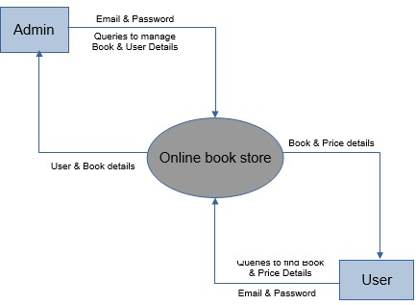

**DFD: LEVEL 1 (USER**)

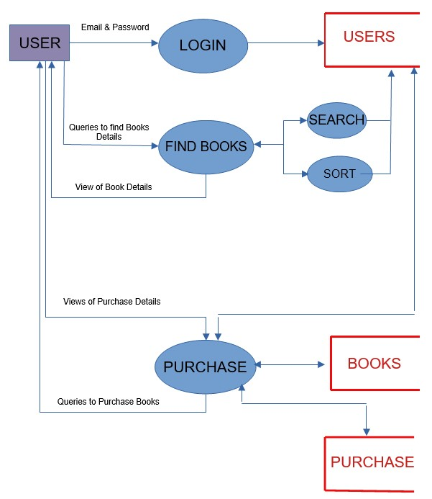

**DFD : LEVEL 1 (ADMIN**)

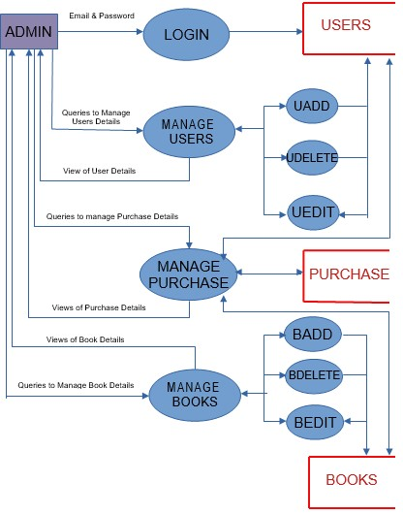

**SYSTEM TESTING**

**SYSTEM TESTING**

**5.1 Testing Procedures**

The purpose of system testing is to identify and correct errors in the candidate system. Testing is an important element of the software quality assurance and represents the ultimate review of specification, design and coding. The increasing visibility of the software as a system element and the costs associated with a software failure are motivated forces for well planned, through testing.

Software testing is a critical element of the software development cycle. The testing is essential for ensuring the Quality of the software developed and represents the ultimate view of specification, design and code generation. Software testing is designed as the process by which one detects the defects in the software. Testing is a set activity that can be planned and conducted systematically. Testing begins at the module level and work towards the integration of entire computer-based systems. During testing the system is used experimentally to ensure that the software does not fail, i.e., it will run according to the specification and in the way the user expects. Preparation of test data plays n vital role in the system testing. Different set of test data are generated and the system under study is tested using that data.

A good test case is one that has a high probability of finding an as-yet undiscovered errors. A successful test is one such uncovers or finds such errors. If testing is conducted successfully; it will uncover errors in the software. It also demonstrates that software functions are being performed according to specification and also behavioural and performance requirements are satisfied. For this, test plans have to be prepared. The implementation of a computer system requires that test data has to be prepared and that the book stall management system as well as its elements is being tested in a planned and efficient manner. Nothing is complete without testing, as its vital success of the system.

**5.2 Testing Methodologies**

The candidate system is subject to verify of test to determine the response time and security. Different testing methodologies are applied before the system is tested for user acceptance.

**UNIT TESTING**

In unit testing the analyst tests the programs making up a system. Unit testing gives stress on the modules independently of one another, to find errors. This helps the tester in detecting errors in coding and logic that are contained within that module alone. The errors resulting from the interaction between modules are initially avoided. Unit testing can be performed from the bottom up, starting with smallest and lowest-level modules and proceeding one at a time. For each module in bottom-up testing a short program is used to execute the module and provides the needed data, so that the module is asked to perform the way it will when embedded within the larger system.

Unit testing deals with testing a unit as a whole. This would test the interaction of many functions but confine the test within one unit. The exact scope of a unit is left to interpretation. Supporting test code, sometimes called scaffolding, may be necessary to support an individual test. This type of testing is driven by the architecture and implementation teams. This focus is also called black-box testing because only the details of the interface are visible to the test. Limits that are global to a unit are tested here.

In software testing, one particular test may need some supporting software. This software establishes an environment around the test. Only when this environment is established can a correct evaluation of the test take place. The scaffolding software may establish state and values for data structures as well as providing dummy external functions for the test. Different scaffolding software may be needed from one test to another test. Scaffolding software rarely is considered part of the system. Sometimes the scaffolding software becomes larger than the system software being tested. Usually, the scaffolding software is not of the same quality as the system software and frequently is quite fragile. A small change in the test may lead to much larger changes in the scaffolding.

**INTEGRATION TESTING**

This testing level can be simply defined as integrating and then testing. i.e., here, many unit-tested modules are combined into subsystems, which are then tested. Integration testing aims at whether the modules can be integrated properly. Hence, the emphasis is on testing interfaces between modules. This testing activity can be considered testing the design.

Integration testing takes as its input modules that have been unit tested, groups them in larger aggregates, applies tests defined in an integration test plan to those aggregates, and delivers as its output the integrated system ready for system testing. The purpose of integration testing is to verify functional, performance and reliability requirements placed on major design items.

**SYSTEM TESTING**

The important and essential part of the system development phase, after designing and developing the software is system testing. Theoretically, a newly designed system should have all the parts or sub-systems are in working order, but in reality, each sub-system works independently. This is the time to gather all the subsystem into one pool and test the whole system to determine whether it meets the user requirements. The purpose of system testing is to consider all the likely variations to which it will be subjected and then push the system to its limits.

**VALIDATION TESTING**

Validation can be defined that it succeeds when the software functions in a manner that can be reasonably expected by the customer. Software validation is achieved through a series of black box tests that demonstrate conformity with requirements. An important element of the validation process is a configuration review. The intent of the review is to ensure that all the elements of the software life cycle. It is virtually impossible for software developer to foresee how the customer will use the program.

When custom software is built for one customer a series of acceptance tests are conducted to enable the customer to validate all requirements. Conducted by the end user rather than the system developer, an acceptance tests can range from an informal ‘test drive’ to a planned systematically executed series of tests. In fact, acceptance testing can be conducted over a period of weeks or months, thereby uncovering cumulative errors that might degrade the system overtime.

**SYSTEM IMPLEMENTATION AND MAINTENANCE**

**SYSTEM IMPLEMENTATION**

An important aspect of system analyst’s job is to make sure that the new design is implemented to established standard. Implementation is used here to mean the process of converting a new or a reversed system design into operational one. There are three types of implementation

* Implementation of a computer system to replace a manual system. The problems encountered are converting files, training users, creating accurate and verifying print outs for integrity.
* Implementation of a new computer system to replace the existing one.
* Implementation of modified application to replace an existing or, using the same computer. This type of conversion is relatively easy to handle

**Conversion**

Conversion means changing from one system to another. The objective is to put the system into operation while holding costs, risks and personal irritation to a minimum. It involves

* Creating computer compatible files.
* Training the operating staff.
* Installing terminals and hardware.

**User Training**

The analyst must have clear idea about the user’s capacity and requirement. A well-designed system may fail because of the way are operated and used. So, the user must be trained before using the new system and the quality of the training must be high

**SYSTEM MAINTENANCE**

**System Security and Backup**

The implementation phase is the rollout of the production version of the system to the client community. This involves tasks like backing up the existing system, data conversions producing user documentation.

**Security**

Security is an essential part of the increased scale of computerization and the development of the system like sensitive area.

**Back up**

Backups for hardware, the data and the system are inevitable factor to be considered. Data backup represents insurance against actual loss of data due to equipment malfunction. Program failure or accident. Hence data can be providing on hard disk or on floppy disk.

**Documenting the System**

After the jobs of testing were completed the whole system as well documented in clear, Understandable and simple language. This was to ensure that if any updating has to be performed in the future the users would not face any difficulties in performing tasks. An acceptance was made to attain maximum perfection in documentation the software in a simple, precise and self-explanatory manner.

The documentations deal with the system development with maximum clarity. Each and every process is explained in details. The various tables used by the system with their fields are provided. Different types of programs denoting various activities of the system are included. The testing methods adopted also from a part of the document. The output generated by the system constitutes another part.

FUTURE SCOPE OF THE

PROJECT

**FUTURE SCOPE OF THE PROJECT**

Future expansions of the project depend upon automatically generating reports for purchase and sales, online purchasing facility for customers. Shops could implement the **ONLINE BOOK STORE**, as it is simple and user friendly. Making enhancements is all about perfective maintenance. It means adding, modifying or redeveloping the code to support changes in the specifications. It is necessary to keep up with changing user needs and the operational environment. More money and time are spent on perfective maintenance than on corrective or adaptive maintenance together. The main advantage of the proposed system is that we can easily access and maintain the customer information and it helps in saving the time and also reduces the cost and manual effort.

CONCLUSION

**CONCLUSION**

It is believed that almost all system objectives have been met. A trial run of the system has been made and is giving good results. The procedure for processing is simple and regular in order.

The system has been developed keeping in view of the limitations of the existing manual system and attempt has been made to overcome the limitations. It would render faster and better services to the user. System has got the feature of easy generation of various reports of which new system will almost definitely be preferred over the existing system. However, modification can be made depending on the changing environment.

For maximum utilization of the system, users should make sure that all the data entries should be complete. This project work is not without drawbacks even though 'it is unique in its nature.

**BIBLIOGRAPHY**

**BIBLIOGRAPHY**

Book Referred:

* Elias M Award, “System Analysis and Design”, Galgotia publications, New Delhi, 2002
* C J Dale, “An Introduction to Database Management” ϖ James Martin, “Database Management System”
* Robin Nixon, “Learning PHP, MySQL, and JavaScript”

ONLINE REFERENCES

1.https://en.wikipedia.org/wiki/Database

2. https://en.wikipedia.org/wiki/Systems_development_life_cycle

3. https://www.mysql.com

4.https://Appache.org

**APPENDIX**

**LOGIN**



**USER REGISTERATION**



**CONTACT US**

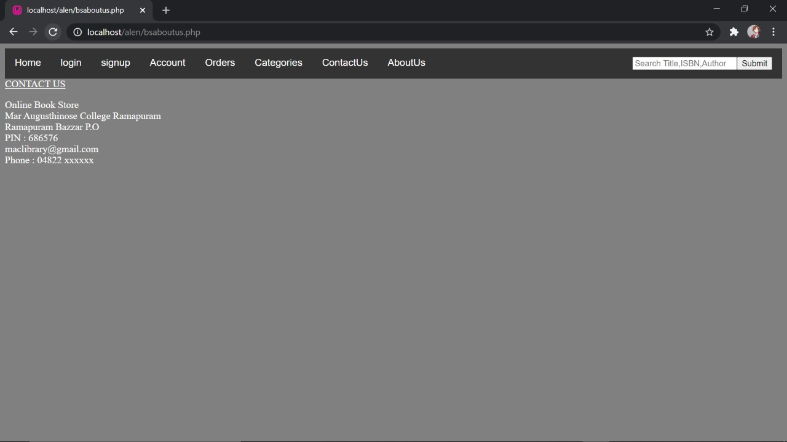

**ABOUT US**

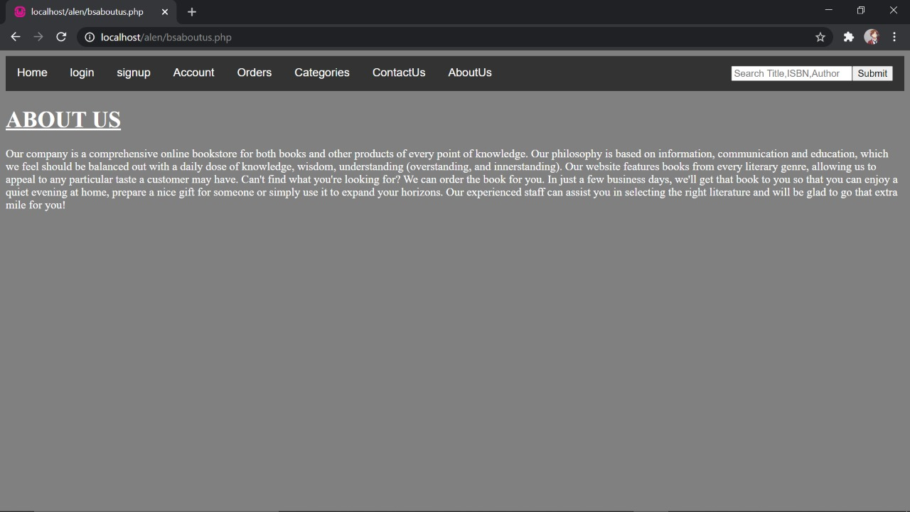

**ADMIN**

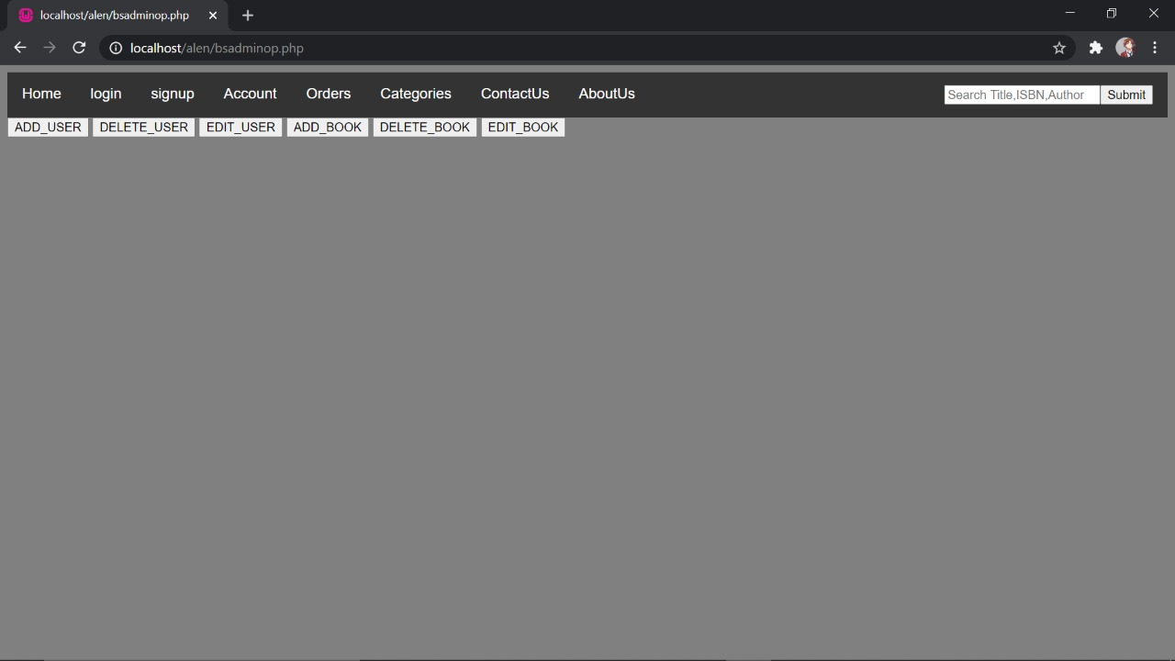

**BOOK DETAILS**

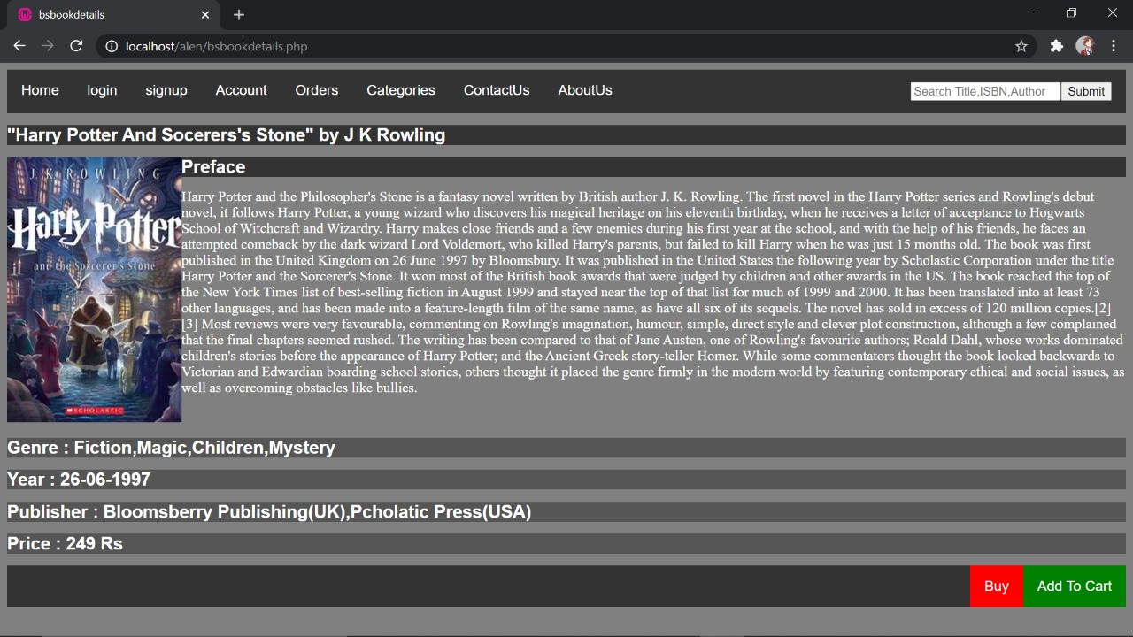

**HOME**

